**FORMAT LEMBAR PENGESAHAN DALAM BAHASA INGGRIS BAGI MAHASISWA ANGKATAN 2017 DAN SETELAHNYA**

**TITLE OF UNDERGRADUATE FINAL PROJECT**

**STUDENT NAME**

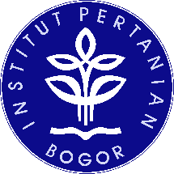

**DEPARTMENT OF AGROINDUSTRIAL TECHNOLOGY**

**FACULTY OF AGRICULTURAL ENGINEERING AND TECHNOLOGY**

**IPB UNIVERSITY**

**BOGOR**

**YEAR**

**TITLE OF UNDERGRADUATE FINAL PROJECT**

**STUDENT NAME**

Undergraduate Final Project

As one of the requirements for obtaining a degree of

Bachelor of Engineering with Honours

at

Department of Agrioindustrial Technology

**DEPARTMENT OF AGROINDUSTRIAL TECHNOLOGY**

**FACULTY OF AGRICULTURAL ENGINEERING AND TECHNOLOGY**

**IPB UNIVERSITY**

**BOGOR**

**YEAR**

Examiner’s Committee:

1. Muhammad Arif Darmawan, S.TP, M.T

Title of Final Project :

Student Name :

Student ID :

Approved by:

Supervisor:

Supervisor’s Name

Co-Supervisor:

Supervisor’s Name

Acknowledged by:

Head of Department:

Prof. Dr-Ing. Ir. Suprihatin

NIP. 196312211990031002

Date of Exam: Date of Approval: